CLEEVE CLOUD GOLF CLUB

LADIES OPEN
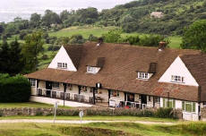
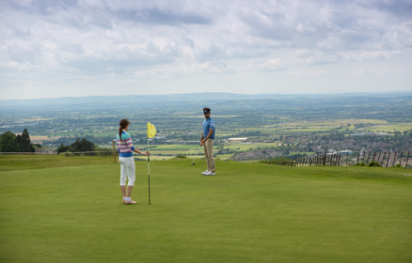
Sunday 27 September 2020

Pairs Betterball Stableford

Max Handicap 36

A chance to enjoy Cleeve Hill Golf Course with its
Glorious Views & Interesting Challenges!

---------------------------------------------------------------------------------------------------------------------------------
Cleeve Cloud Ladies Open – Sunday 27 September 2020

Closing date for entries: 13 September 2020

£24 per pair (if you need a partner, phone or email)

Your Name, Phone number & Email for contact: .....................................................................................................
.....................................................................................................
MAX HANDICAP 36
1st Pair

Name: CDH:
Handicap:
Golf Club:

Name: CDH:
Handicap:
Golf Club:

2nd Pair

Name: CDH:
Handicap:
Golf Club:

Name: CDH:
Handicap:
Golf Club:
--------------------------------------------------------------------------
Email entries (preferable) to: jazzyk1@icloud.com - details will be provided for payment.

Postal entries and cheques to:
Jasmine Kapadia, Cleeve Cloud Golf Club, Cleeve Hill, Cheltenham, Gloucestershire GL52 3PW

Cheques payable to:
Cleeve Cloud Golf Club Ladies Section

Extra entries can be written on the back of the form.
Your acknowledgement of entry & tee times will be sent by email.
If you wish to receive them by post please enclose a stamped, addressed envelope.

Enquiries: jazzyk1@icloud.com or call 07497 044104

