CLEEVE CLOUD GOLF CLUB

LADIES OPEN
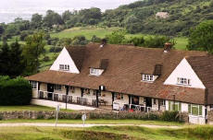
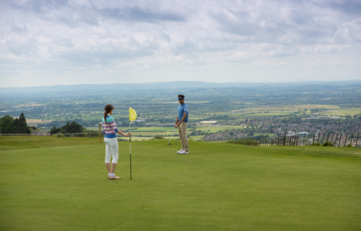
Sunday 14th April 2019

Pairs Betterball Stableford

Max Handicap 36

A chance to enjoy Cleeve Hill Golf Course with its
glorious views & interesting challenges

---------------------------------------------------------------------------------------------------------------------------------
Cleeve Cloud Ladies Open – Sunday 14th April 2019

Closing date for entries: 16th March 2019

£24 per pair (if you need a partner, phone or email)

Name, phone number & email for contact .......................................................................................

..........................................................................................................................................................
MAX HANDICAP 36
1st Pair
Name ......................................................................CDH......................................H’cap..................

Golf Club........................................................................................

Name ......................................................................CDH......................................H’cap..................

Golf Club........................................................................................

2nd Pair
Name ......................................................................CDH......................................H’cap..................

Golf Club........................................................................................

Name ......................................................................CDH......................................H’cap..................

Golf Club........................................................................................

Your acknowledgement of entry & tee times will be sent by email.
If you wish to receive them by post please enclose a stamped, addressed envelope.
Extra entries can be written on the back of this form.
Entry forms to:  Mrs Gillian Cowell  Cleeve Cloud Golf Club  Cleeve Hill  Cheltenham  Glos GL52 3PW | Cheques payable to:  Cleeve Cloud Golf Club Ladies Section  Enquiries: Gillian Cowell  Email: cleevecloudladies@gmail.com  Tel: 0779 100 5392

